Adder
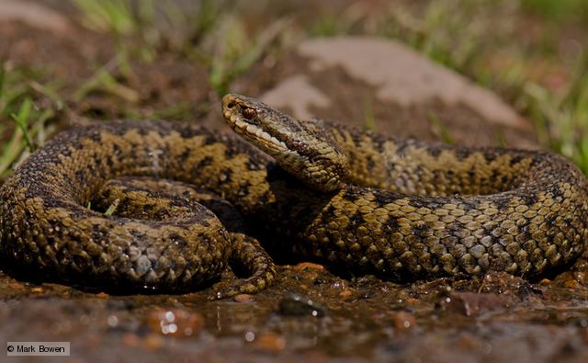

Adder (Vipera berus)
The adder is the only venomous snake native to Britain. Adders have the most highly developed venom injecting mechanism of all snakes, but they are not aggressive animals. Adders will only use their venom as a last means of defence, usually if caught or trodden on. No one has died from adder bite in Britain for over 20 years. With proper treatment, the worst effects are nausea and drowsiness, followed by severe swelling and bruising in the area of the bite. Most people who are bitten were handling the snake. Treat adders with respect and leave them alone.

Adders are relatively common in areas of rough, open countryside and are often associated with woodland edge habitats. The best time to see them is in early spring when they emerge from their hibernation dens.

Adders usually eat small rodents, such as the short-tailed vole. They will also eat lizards, frogs and newts, and have been seen taking young from the nests of ground nesting birds. When hunting, adders strike swiftly at the prey, injecting a lethal dose of venom. They then wait until the prey dies before starting the lengthy swallowing process. Like all snakes, adders eat their prey whole, their teeth are designed to grip the prey as it is swallowed. Their jaws are linked by extensible connective tissue so each of the four main bones can move independently. This means they are able to swallow items much larger than the width of their head. The lower ends of the ribs are not joined as in most animals and can also open out considerably. The adder's digestive fluid is amazingly powerful and will digest the flesh and bones of their prey almost completely. Only the hair and teeth of rodents pass through intact.
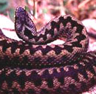
Most adders are distinctively marked with a dark zigzag running down the length of the spine and an inverted 'V' shape on the neck. Males are generally white or pale grey with a black zigzag. Females are a pale brown colour, with a darker brown zigzag. But some adders are entirely black and can be mistaken for some other species.

