ASMA YAPRAĞI
GRAPES LEAVES

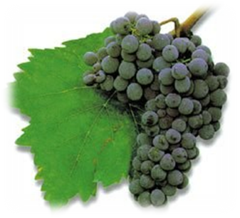
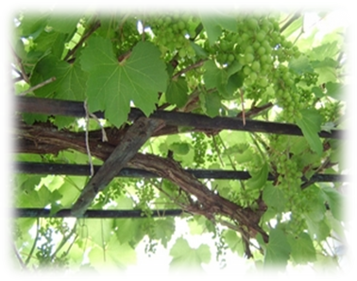
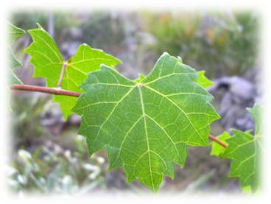
Grapes Leaf is very important for Turkish People. It symbolizes fertility, blessing and prosperity. We plant grapes around arbors in front our our houses. We cook “sarma” from grapes leaves. Here is a short recipe and a photo for you if you want to try it. Prepare a bowl of rice with spices you like. Then put some rice on the leaf. Roll it as it is shown in the photo. Finally put them in a pot and cook after adding some olive oil and salt. Preparing this delicious traditional Turkish food takes long hours but be sure it takes just seconds to eat it!


