Fox
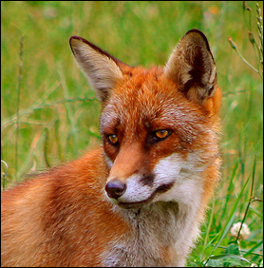

Origin: | Native.
Size: | Head / body length 62 - 72 cm plus tail 39 - 41 cm. Females are slightly smaller  than males.  Weight: male 6.7 kg, female 5.4 kg.
Description: | Coat is variable in colour. It is usually reddish, but can be orange or yellow with  a dark stripe down the back. The under parts are white, grey or slate in colour.  Limbs are commonly black.  Tip of the tail ('brush') is usually white.
Habitat: | Almost every habitat; sea cliffs, sand dunes, salt marshes, peat bogs,  high mountains, woodland and particularly abundant (14%) in urban areas.
Young: | 1 litter annually in March; 4 - 5 cubs born underground in an 'earth'.  This is either dug by the fox in hillocks or banks. They may occupy a disused  badger sett or enlarge a rabbit burrow.
Diet: | Field voles, birds, rabbits, insects, earthworms, grasshoppers, beetles,  blackberries, plums, and carrion. Surplus food is buried.
