Garden documentary of GGS Ennertschule
Bonn
Germany

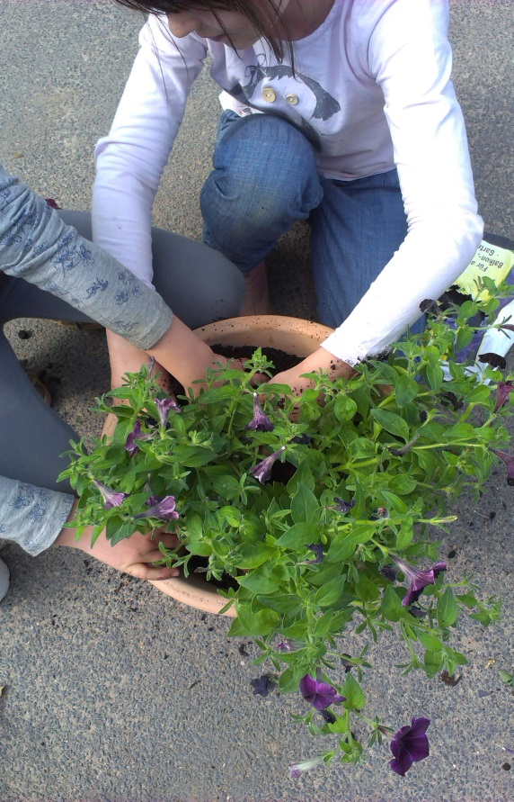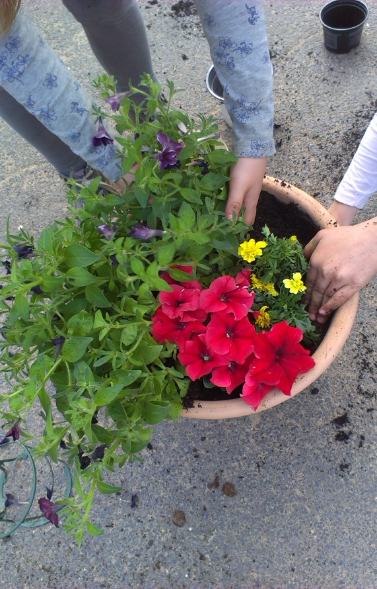

The children of class 1c helped to plant the flowers in the colours of the national flag. At first it was tough to find black flowers. Fortunately we found black petunias.
We are going to seed more flowers in flower pots and around the Comeniuis-Tree to make our school more colourful.

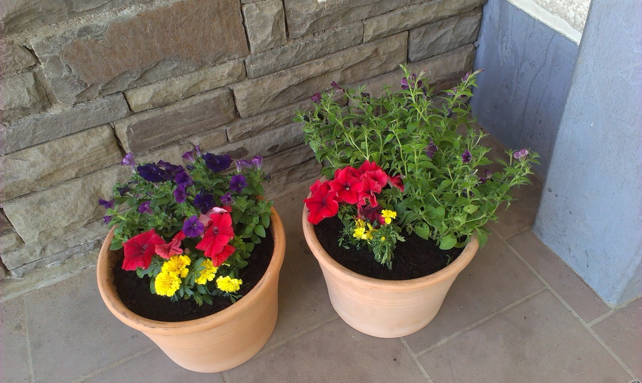

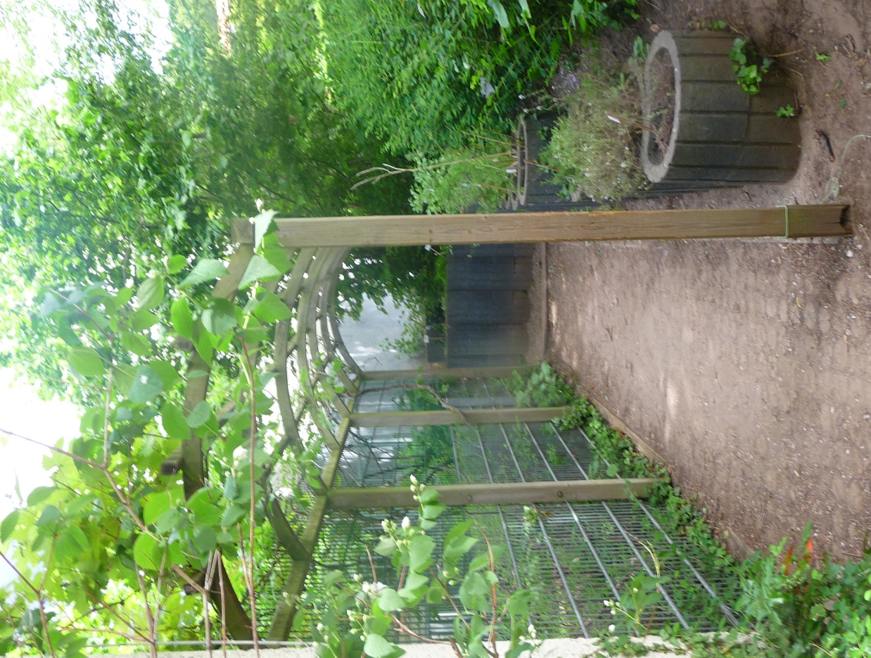

This is our access balcony. The children use this way to get from one schooyard to the other. Some also like to spend some time during the break to recreate.
On the left hand side is our biotope. On the right hand side children of a second class cultivated different herbs.
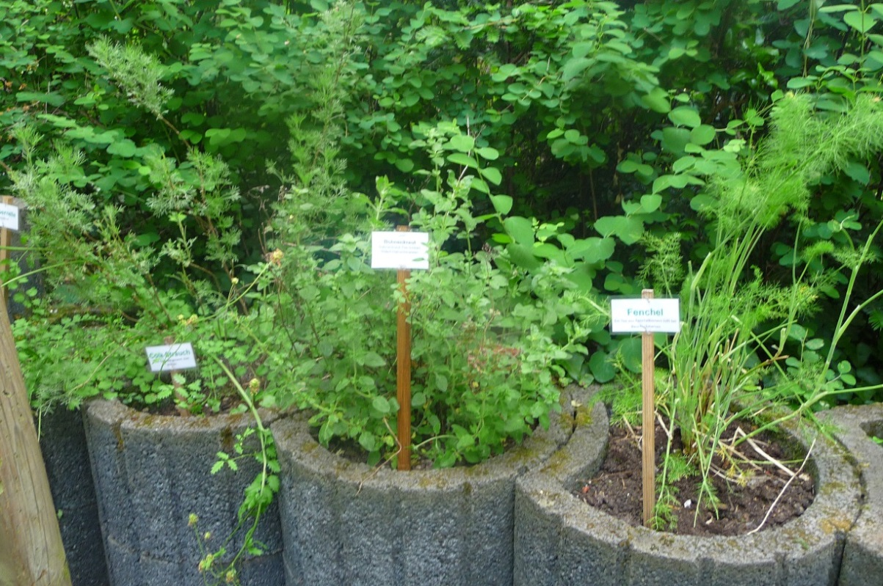
Children cultivated different herbs along the access balcony. We are planning to cultivate tomatoes, bush beans and potatoes, too. Unfortunately the soil on our schoolground is so hard, that we aren´t able to plant something in the earth, yet. Therefore we´ll try to cultivate the plants in flower pots. As you can see in our short film, the children like to play tag or hide and seek in the bushes. This is our environmental problem at school, because nothing can grow because it´s stamped down. That´s the reason why the soil is so hard. But we´ll do our best that the children play on the schoolyard so that we are able to plant more different flowers to make our schoolground more colourful.
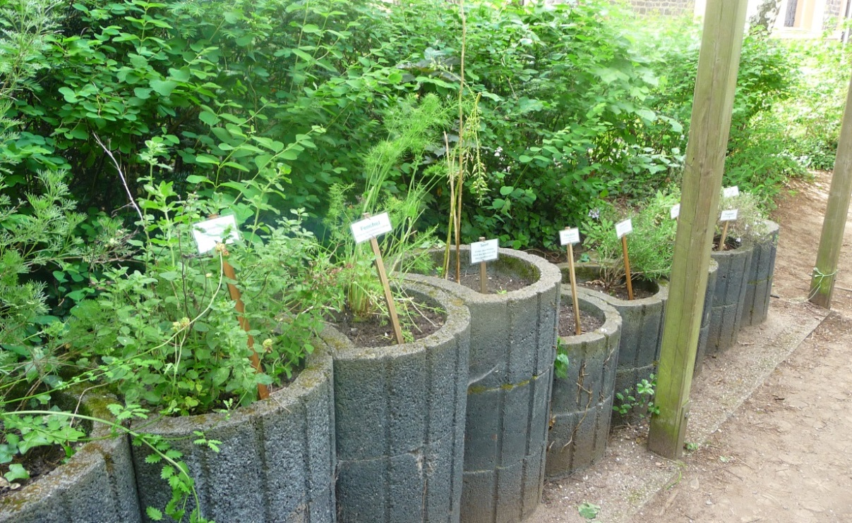

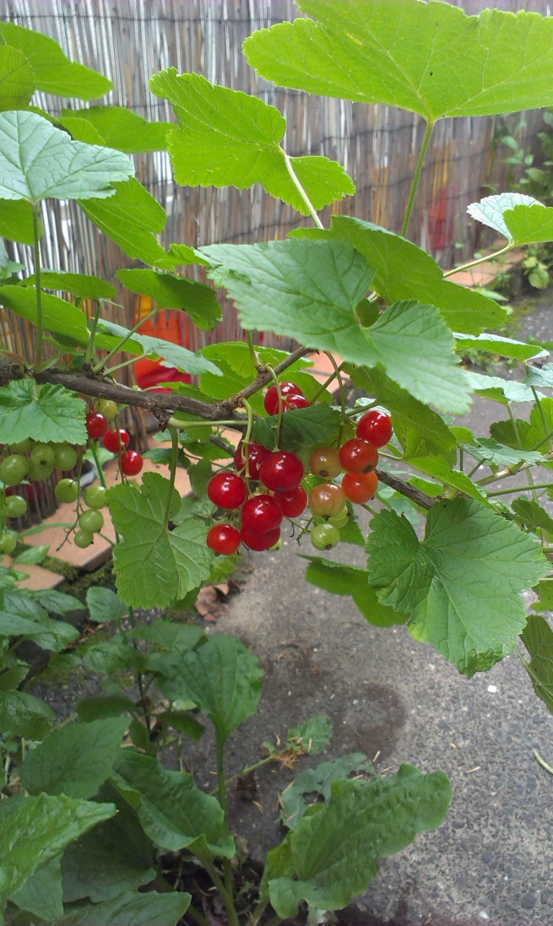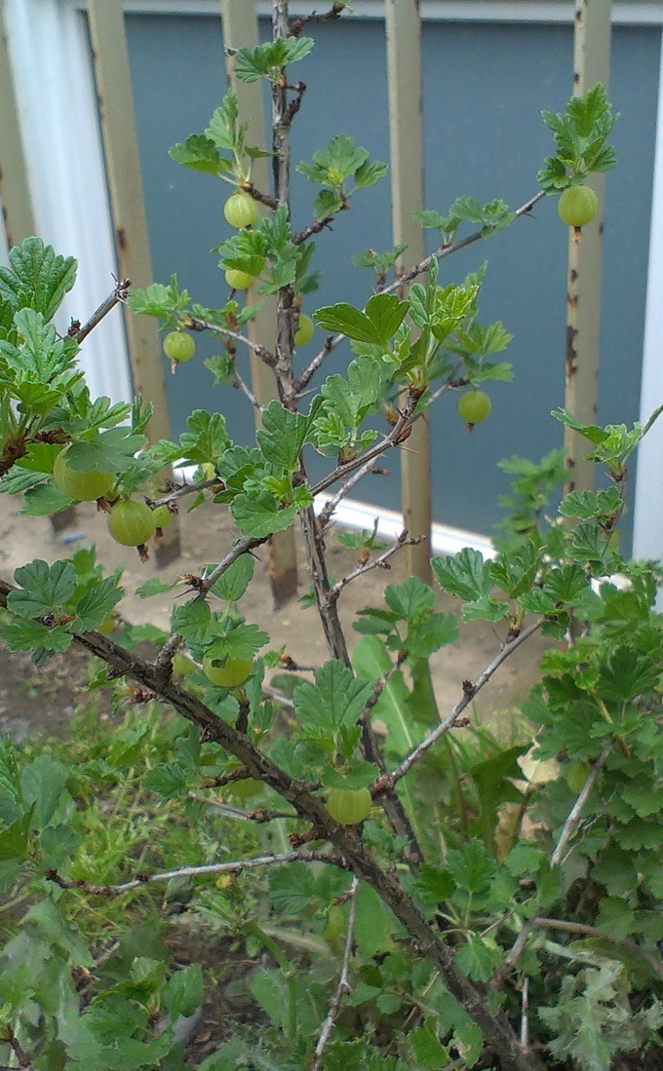

On the small schoolyard we planted red currant. In a couple of days we can gather the first fruits and can enjoy them.
On the big schoolyard we planted gooeseberry. There are already some small fruits growing.
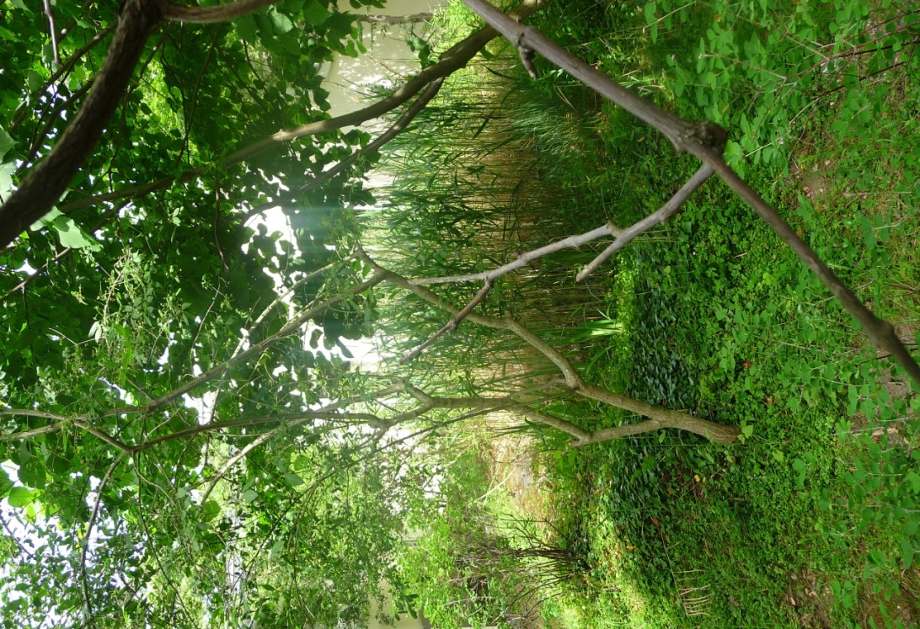
This is an image of our biotope.
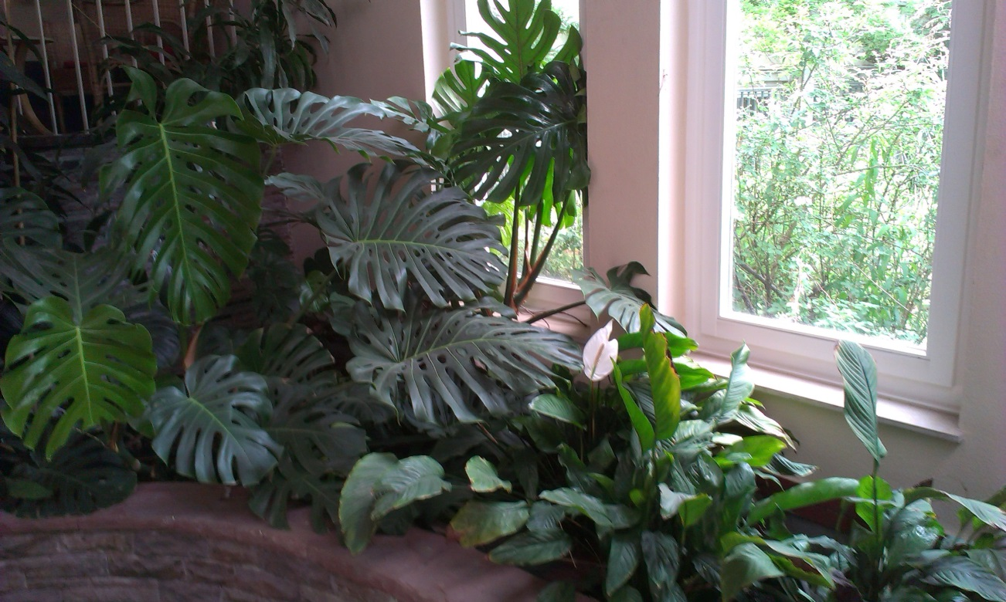
This is our green flower bed inside the school building.

