Hazel
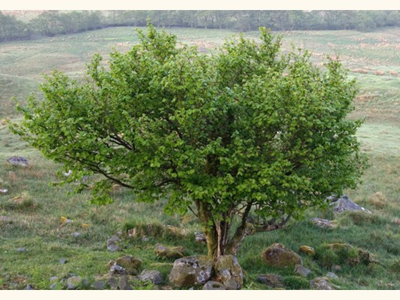

Hazel(Corylus avellana)
Hazel is a deciduous broadleaf tree native to the UK.

Hazel is often coppiced (trimmed down), but when left to grow, trees can reach a height of 12m, where it can live for up to 80 years (if coppiced, hazel can live for several hundred years). It has a smooth, grey-brown, bark, which peels with age, and bendy, hairy stems. Leaf buds are oval, blunt and hairy, and the leaves are round to oval, doubly toothed, hairy and pointed at the tip. Leaves turn yellow before falling in autumn.

Both male and female flowers are found on the same hazel tree, although hazel flowers must be pollinated by pollen from other hazel trees. The yellow male catkins appear before the leaves and hang in clusters, from mid-February. Female flowers are tiny and bud-like with red styles. Once pollinated by wind, the female flowers develop into oval fruits, which hang in groups of one to four. They mature into a nut with a woody shell surrounded by a cup of leafy bracts (modified leaves).

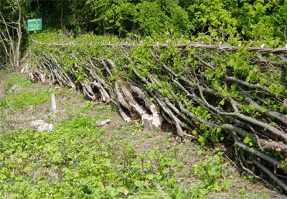
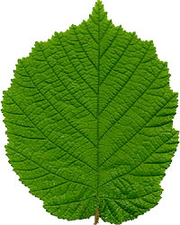
Interesting fact: hazel is so bendy in spring that it can be tied in a knot without breaking.

