KARDELEN---SNOWDROP

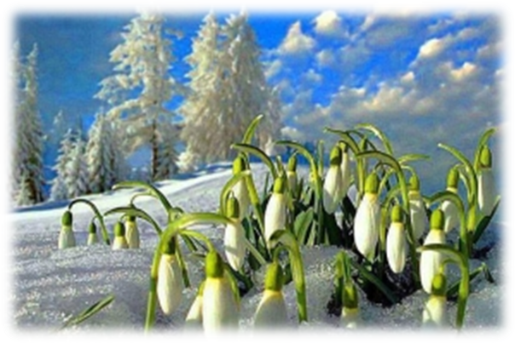
Kardelen is an interesting, astonishing, elegant and rare flower. Some of its species are typical to Turkey. There is even a story about it. Kardelen is in love with sun but it knows that sunshine is dangerous for its fragile leaves. It prays God to see sun once. God accepts and puts it under snow to protect its leaves. When spring comes, it grows and cranes to see sun. It looks at the sun so long that it starts to burn. It dies in love at the end. Don’t be sad, it is just a story, have a look at this beautiful flower. There are even some colorful versions of it.


