The Ennertschoolgarden

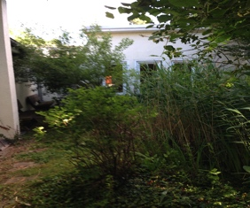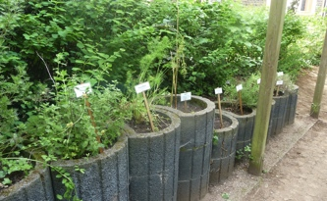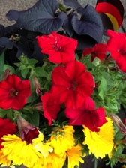
Our schoolgarden Children cultivated different herbs The flower bed flag
along the access balcony.

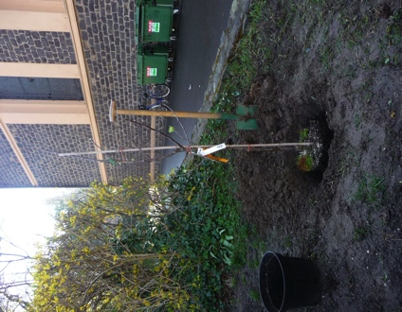

The Comenius tree
We decided to plant an apple tree. We´ve planted the tree under our European flag at the entrance of our schoolground. It´s small right now, but big and hopefully rich of fruits one day. The apples will be red and they´ll taste sweet. Children from class 4c and 1c helped to plant it.

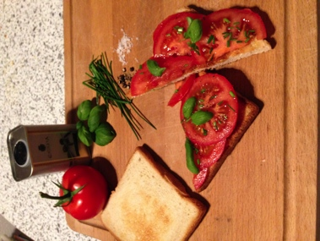

Tomatosandwich
with fresh basil

Ingredients:
1 slice of toast, 1 tomato, teaspoon olive oil, 2 fresh leaves basil, 1 teaspoon chives , salt and pepper
1 Roast the toast.
2 Wash the tomatoes and slice them.
3 Cover the toast with the slices and season with salt and pepper and a teaspoon of olive oil.
4. Sprinkle fresh basil leaves and chives over it and enjoy.

